**Experiment No. 1.3**

**Student Name: Rishav Kumar UID: 22MCC20039**

**Branch: MCA - CCD Section/Group: MCD-1/ Grp A**

**Semester: IV Date of Performance: 25th Jan 24**

**Subject Name: Big Data Analytics Subject Code: 22CAP-782**

1. **Aim/Overview of the practical:**

Upload and Download a file in Hadoop

1. **Code for practical:**

* Open terminal in Ubuntu and use following command to switch user:
* Start servers using command:

***start-all.sh***

* After starting namenodes and datanodes, make a local folder named localData.

***mkdir localdata***

* Make a new file in localData city.txt using touch or vim.
* To upload it on Hadoop use command:

***hdfs dfs -put home/hadoop/localdata/city.txt /hadoopdata***

* To view it use ls command:

***hdfs dfs -ls /hadoopdata***

* To download/copy file from Hadoop server to local, use command -get:

***hdfs dfs -get /hadoopdata/city.txt /home/hadoop***

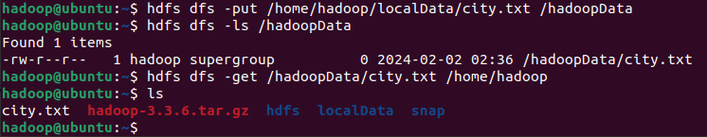

**************************************** **THE END** ***********************************************